COVERING LETTER
Title
Unsupervised multimodal MR images segmentation and MS lesions extraction based on edge and texture features
Authors full names:
Tannaz Akbarpour , Mousa Shamsi, Sabalan Daneshvar, Masoud Pooreisa
The authors confirm that:
•The corresponding author is empowered by all authors to act on their behalf with respect of the submission of the manuscript.
• All authors have participated sufficiently in this paper to take public responsibility for its content.
•Institutional affiliation of all authors of the manuscript is proper and does not imply a conflict of interest.
• The submitted manuscript has been reviewed and approved by all authors.
•Neither this manuscript nor a manuscript with similar content or research under my/our authorship has been published in any language or was sent for publication elsewhere (excepting as an abstract or as
part of a published lecture or thesis)
•The corresponding authors have informed the editor (in the manuscript or in additional letter) of
Any commercial association that might pose a conflict of interest.
•The manuscript did not contain no materials that would violate the copyright or any other rights of any person or institution.
•By submitting the manuscript (including all illustrations, figures and tables) agree(s) to automatic and free transfer of copyright to the SRIMA Publishing House allowing for the publication and distribution of the material submitted in all available forms and fields of exploitation, without limits of territory or language. Furthermore, the author(s) accept(s) that the submitted manuscript will not be publishing somewhere else in any language without the earlier written permission of the copyright holder (the publisher)
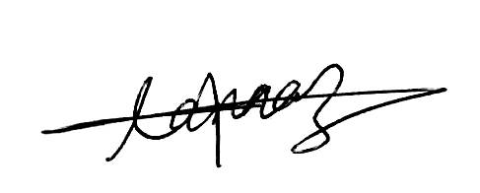  Tannaz Akbarpour | 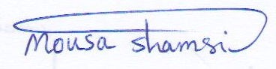  Mousa Shamsi | 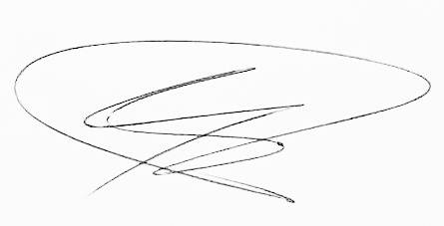  Masoud Pooreisa | Sabalan Daneshvar  